**State University of New York at New Paltz**

**Lee Miller**

**Project Type: Local Project, Student’s p-s17-16: csp01**

**“Library App Map”**

**PROJECT PROPOSAL**

**“Computer Science Projects”**

**Spring 2017**

**(Prof. Hanh Pham)**

**TABLE OF CONTENTS**

**1. Problem Description**

**1.1 Business Context and Goals** ….……………………………………….…………….……. page 03

**1.2 Technical Requirements** ….……………………………………………….……….………. page 03

**1.3 Your Responsibilities** ……...……………………………………………….……….………. page 03

**2. Technologies**

**2.1 Related Technologies** ….……………………………………….……………………..…….. page 04

**2.2 Newly Learned Skills/Technologies …**………………………………..………………. page 04

**3. Plan**

**3.1 Ideas for Solution** ………..……………………………………….……………………..…….. page 05

**3.2 Programming/Coding Components** …….……………………………..………………. page 06

**3.3 Schedule** ………………………………………………………………………………………….... page 10

**1) Project Description:**

1.1 Business Context & Goals:

The Local Library project is working and developing a mapping system for the catalogued books on the library shelves. The web application currently asks for the user to enter a call number of a book, and the application then locates that book within the stacks and displays the books location on a map of the library floors. The library staff are looking to change the application to allow the user to search the catalogue for a book right on the application web page and then have the catalogue search return a call number to the map application and locate the book searched.

1.2 Technical Requirements:

There are many technical requirements for this project to develop what the business, in this case the library, wants. They include:

* Web Programming
* Web Scraping
* Databasing
* PHP Scripting
* JavaScript
* HTML

1.3 Responsibilities:

My group and I must develop an efficient web application for the library that shows the location of a certain book in the library’s possession. In doing this, my group and I must write the actual code for the library application, work with previous developers on the project, testing, and implementation. In addition, the entirety of the library stacks is still not fully mapped and falls under our responsibility to finish mapping the library stacks for the web map application.

**2) Technologies:**

2.1 Related Technology:

Technology related to this project include server communication, and application coding. Many different coding languages are needed to develop, test, and implement this web map application.

2.2 Newly Learned skills and Technology:

Many of my group members, including myself, are new to this type of coding and web programming. We all learned and will be learning new technologies, coding languages, and skills to use in the real world. These include:

* PHP Scripts
* HTTP Protocols
* JavaScript
* HTML
* Web Programming
* Web Scraping
* App Programming

In addition to these technologies, my group members and I learned how to talk to customers, and businesses and extract the responsibilities of the project and what the customer is asking of the developers, project proposals, and presentations of major projects.

**3) Plan:**

3.1 Ideas for Solution:

After talking with the staff at the Library, my group and I devised a few ideas on how to solve the programming problem and come up with a solution. First, we created an imbedded search form that searches the library catalogue. Which we then wrote into the HTML code of the application webpage. From there we developed a PHP web scraper to grab the call number from the system page of the search catalogue. We are currently trying to run the PHP script within the HTML code of the web page. From there we must develop a way for the user to search a book, return the call number of the book and then us that call number to locate the book within the library stacks.

3.2 Programming and Coding Components

* **HTML Catalogue Search** – This code creates a search form which then redirects the user to the library catalogue search.

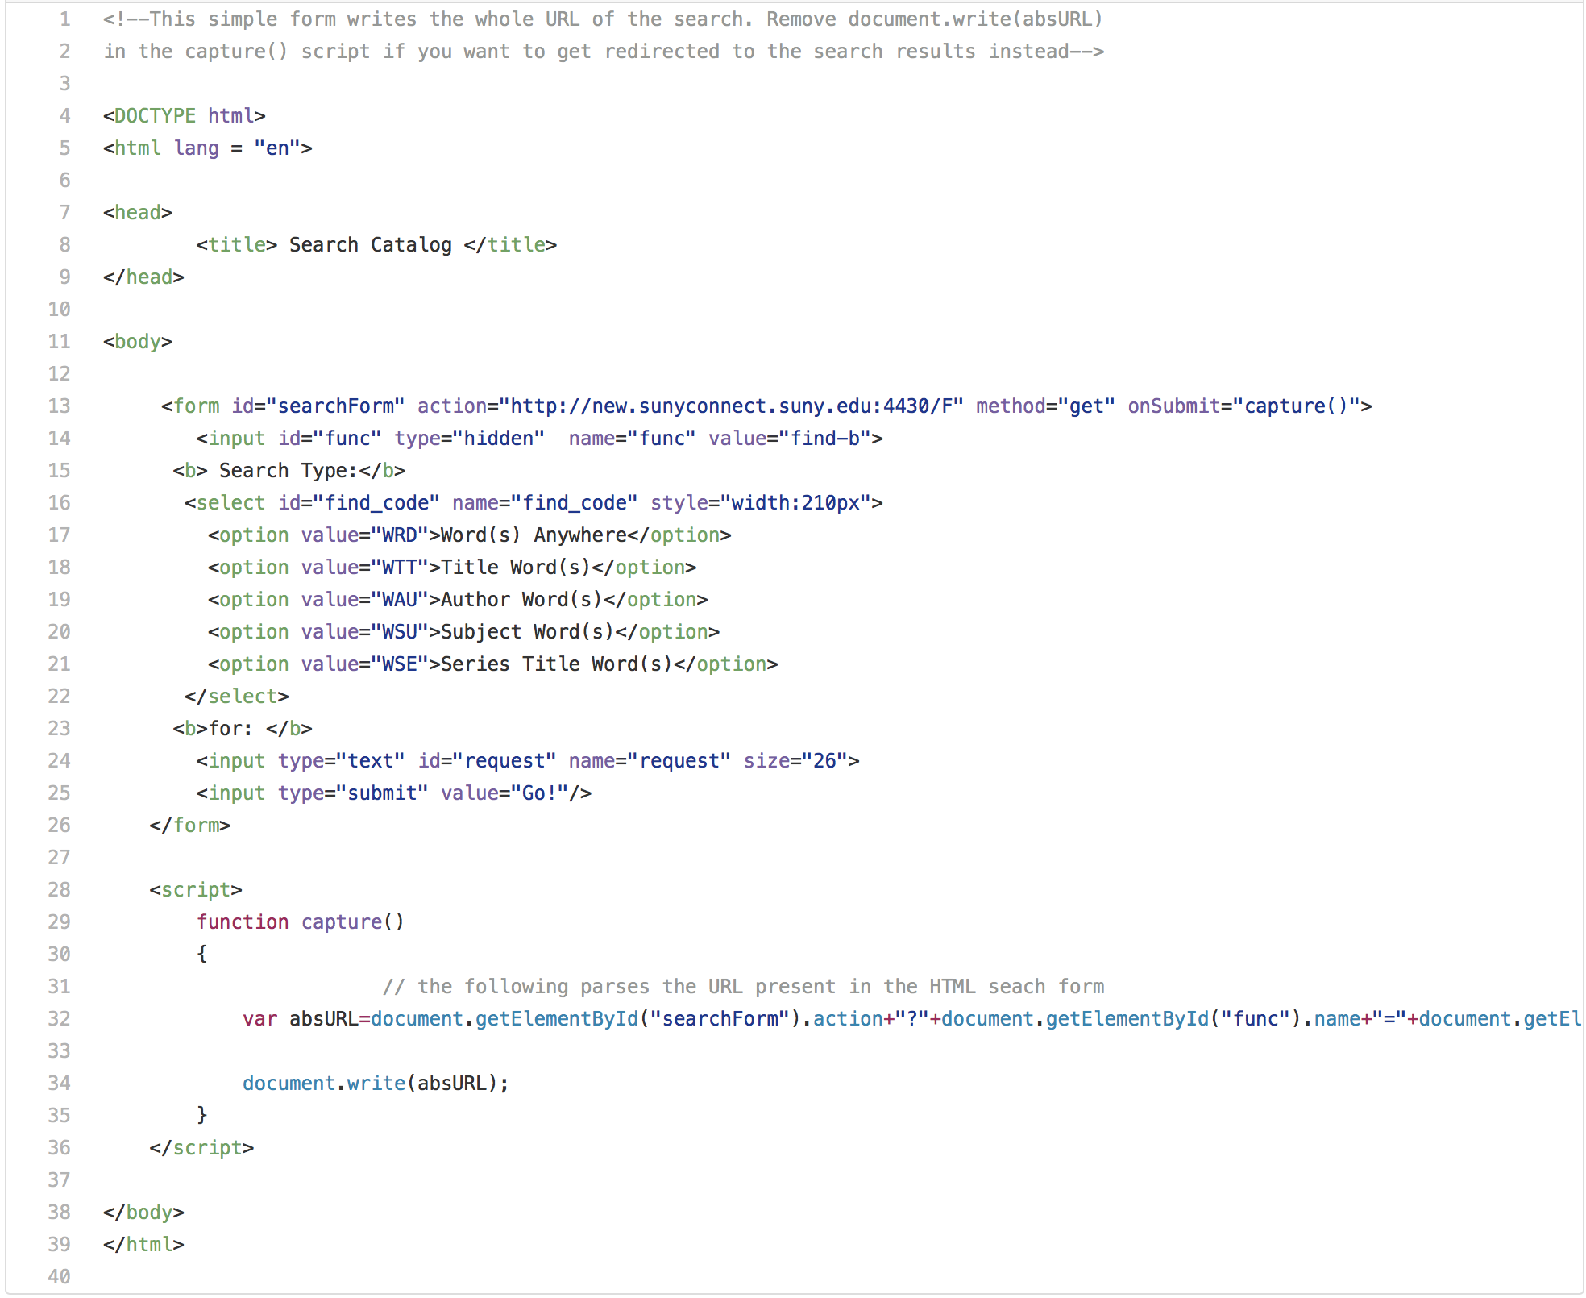

* **PHP Web Scraper** - This PHP script uses the system page link of the library catalogue and then extracts the data, in our case the call number, from the page and returns it to a table.

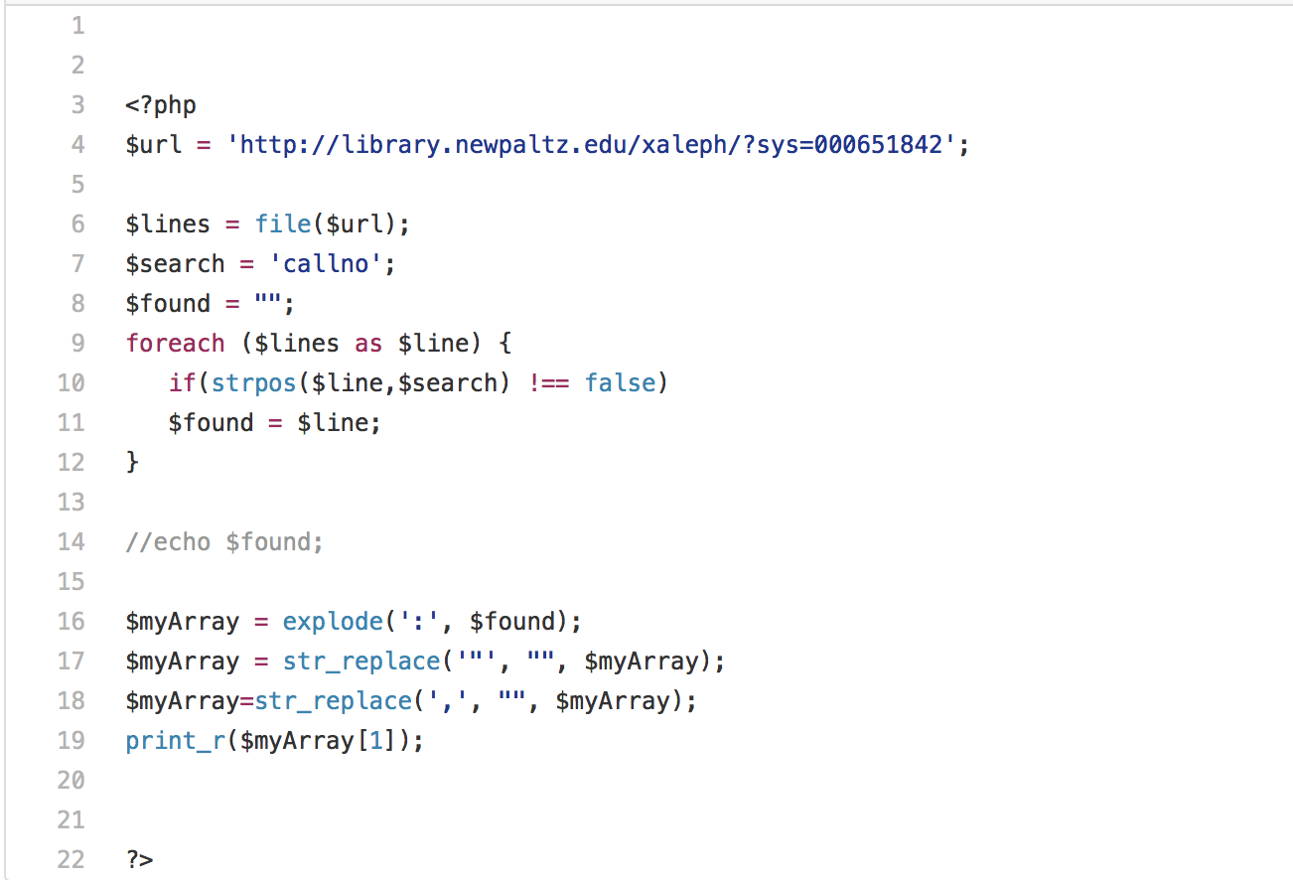

* **HTML Code for the Map Application page with Search Form added:**

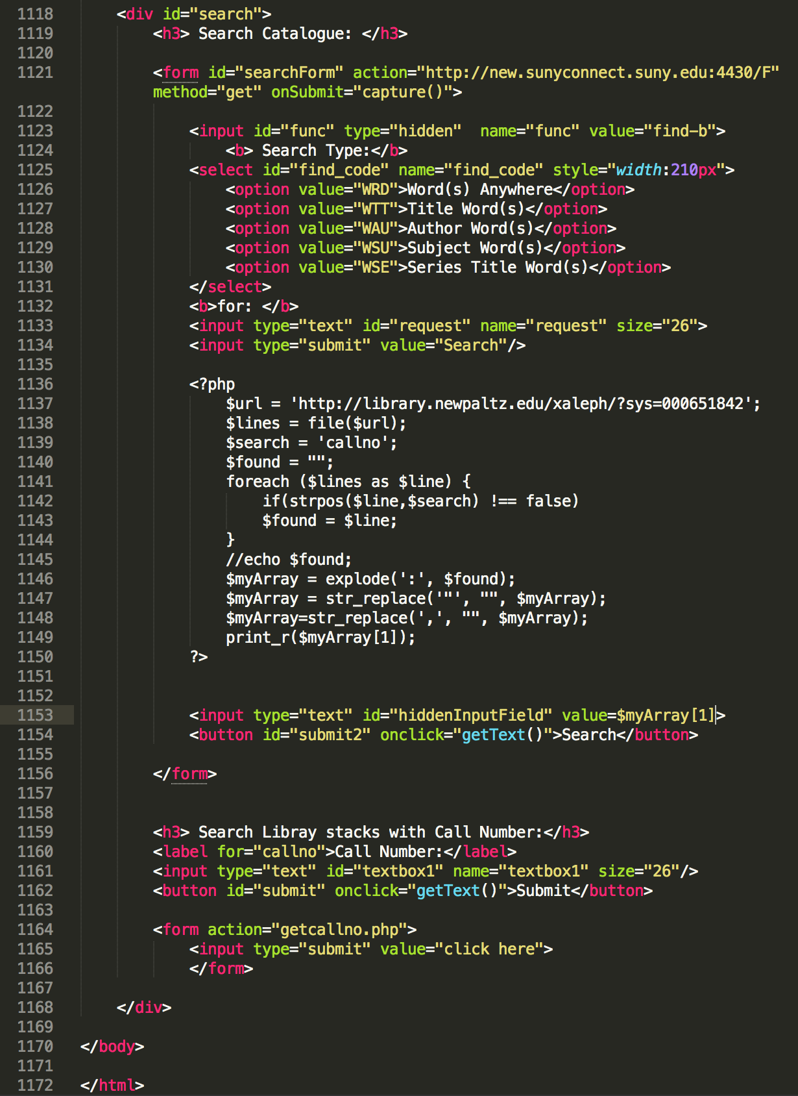

* **Other coding components to be used:**
  + JSON Files
  + HTTP Protocol
  + JavaScript
  + Search Tables
  + HTML

3.3 Schedule:

March – 1 🡪 Web Scraper Development (PHP)

March – 8 🡪 Web Scraper Cont./Create Search Form

March – 15 🡪 Search Form Cont.

March – 22 🡪 Spring Break / Integration of search on map application

March – 29 🡪 Integration of search on map application

April – 5 🡪 Testing

April – 12 🡪 Testing

April – 19 🡪 Final Proposal

April – 26 🡪 Proposal Cont.